Chapter 19, Solution 13.

Consider the circuit as shown below.

10 Ω I₁ I₂

[z]
+
_

+
+
50∠0˚ V V₁
V₂ Z_{L}
_
–

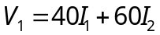 (1)
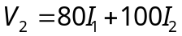 (2)
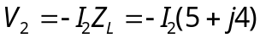 (3)
(4)
Substituting (4) in (1)
(5)
Substituting (3) into (2),
(6)
Solving (5) and (6) gives
I₂ = –7.423 + j3.299 A

We can check the answer using MATLAB.

First we need to rewrite equations 1-4 as follows,

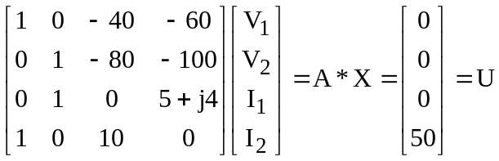

>> A=[1,0,-40,-60;0,1,-80,-100;0,1,0,(5+4i);1,0,10,0]
A =
1.0e+002 *
0.0100 0 -0.4000 -0.6000
0 0.0100 -0.8000 -1.0000
0 0.0100 0 0.0500 + 0.0400i
0.0100 0 0.1000 0
>> U=[0;0;0;50]
U =
0
0
0
50
>> X=inv(A)*U
X =
-49.0722 +39.5876i
50.3093 +13.1959i
9.9072 - 3.9588i
-7.4227 + 3.2990i

P = |I₂|²5 = 329.9 W.

